Personal Data Fair Processing Notice

This notice explains what information I collect, when I collect it and how we use this. During the course of our activities, we will process personal data (which may be held on paper, electronically, or otherwise) about you and we recognise the need to treat it in an appropriate and lawful manner. The purpose of this notice is to make you aware of how we will handle your information.

Who am I?

Steven Tweedie at Grad House Limited, James Watson House, Montgomery Way, Rosehill Industrial Estate, Carlisle, Cumbria, CA1 2UU, take the issue of security and data protection very seriously and strictly adhere to guidelines published in the General Data Protection Regulation (EU) 2016/679 which is applicable from the 25th May 2018, together with any domestic laws subsequently enacted.

I am notified as a Data Controller with the Office of the Information Commissioner under registration number ZA464198 and I am the data controller of any personal data that you provide to us.
Registration reference: ZA464198. Date registered: 10 October 2018. Registration expires: 9 October 2027.

Our Data Protection Officer is Steven Tweedie, Mobile 07496973016 info@gradhouse.co

Any questions relating to this notice and our privacy practices should be sent to info@gradhouse.co or by writing to Grad House Ltd, James Watson House, Montgomery Way, Rosehill Industrial Estate, Carlisle, Cumbria, CA1 2UU.

How we collect information from you and what information I collect

I collect information about you:
- From your application for accommodation
- From any references we may collect to assess your suitability as a tenant
- From any credit reference agencies, we may use these to assess your financial suitability as a tenant

I collect the following information about you:
- Tenant name, e-mail address, telephone number, Date of Birth, address (including any previous addresses), marital status, National Insurance Number, nationality, next of kin, name of university or college where you are studying (if applicable), the name of friends that you are staying with (if applicable);
- Guarantor name, e-mail address, telephone number, Date of Birth, address (including any previous addresses), marital status, National Insurance Number, nationality, next of kin (if applicable);
- Property address; term, rent, deposit, utility and service responsibilities;
- The employment status of tenants and/or guarantors, address, contact details (including email, phone and fax numbers) of the employer/accountant, payroll numbers, length of employment, salary information (including any regular overtime or commission), and any other income received;
- Bank account details of the tenant, including account number and sort code, and any hire purchase/loan agreements/credit cards or store cards that you have; and
- Any welfare benefits that you may be eligible for, or are currently on.

Why I need this information about you and how it will be used

I we need your information and will use your information:
- to undertake and perform our obligations and duties to you in accordance with the terms of our contract with you;
- to enable us to supply you with the services and information which you have requested;
- to help you to manage your tenancy;
- to carry out due diligence on any prospective tenant and/or guarantor, including whether there is any money judgements against them, or any history of bankruptcy or insolvency;
- to analyse the information we collect so that we can administer, support and improve and develop our business and the services we offer;
- to contact you in order to send you details of any changes to our suppliers which may affect you; and
- for all other purposes consistent with the proper performance of our operations and business.

Sharing of Your Information

The information you provide to me will be treated by me as confidential and will be processed only by any third party, acting on my behalf, within the UK/EEA.

I may disclose your information to other third parties who act for us for the purposes set out in this notice or for purposes approved by you, including the following:
- If I/we enter into a joint venture with or merge with a business entity, your information may be disclosed to our new business partners or owners;
- To carry out due diligence on you as a prospective tenant/ guarantor, including but not limited to the carrying out of affordability checks, due diligence checks and the obtaining of references from relevant parties, whose data you have provided;
- If you request so, your information shall be disclosed in order to determine if there are any money judgements against you, as the prospective tenant/guarantor, or to determine if they have a history of bankruptcy or insolvency;
- If you are unable to make payments under your tenancy, your information may be disclosed to any relevant party assisting in the recovery of this debt or the tracing of you as a tenant; and
- In the creation, renewal or termination of the tenancy, your information will be disclosed to the relevant local authority, tenancy deposit scheme administrator, service/utility provider, freeholder, factor, facilities manager or any other relevant person or organisation in connection with this.

Unless required to do so by law, I/we will not otherwise share, sell or distribute any of the information you provide to me/ us without your consent.

Transfers outside the UK and Europe

Your information will only be stored within the UK and EEA.

Security
When you give us information we take steps to make sure that your personal information is kept secure and safe. Here are the places where your data is held along with some details on the security and encryption used to ensure your data is safe:

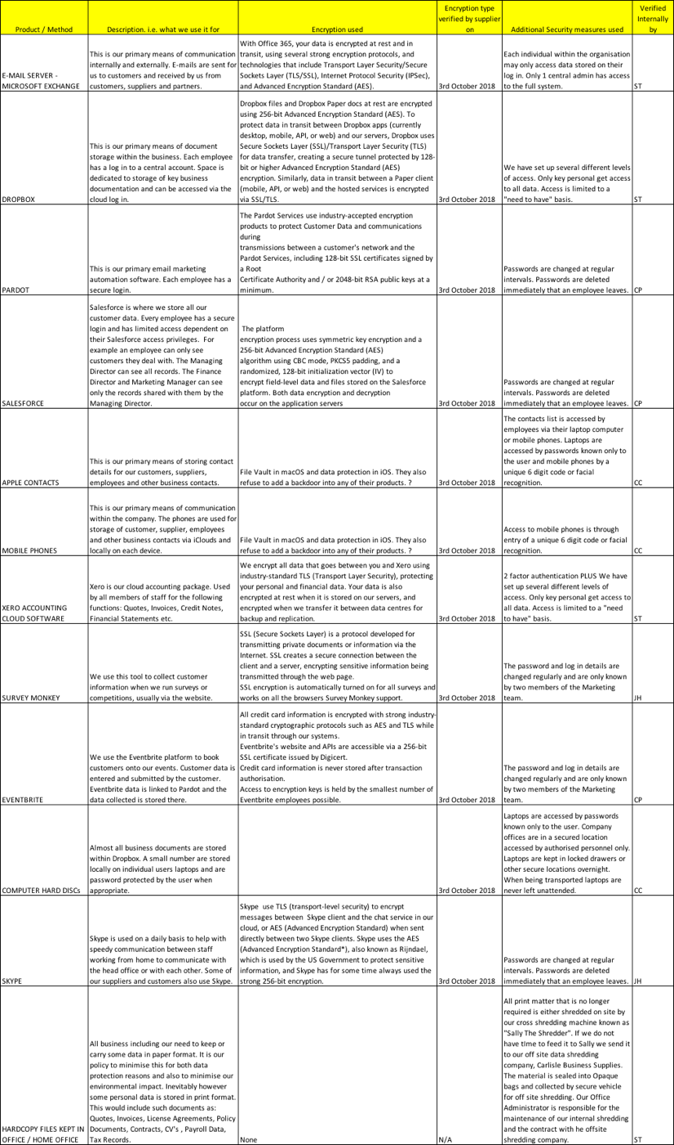
How long we will keep your information

I review my data retention periods regularly and will only hold your personal data for as long as is necessary for the relevant activity, or as required by law (we may be legally required to hold some types of information), or as set out in any relevant contract I have with you.

My full retention schedule is available at our office and I can provide a copy by request to me at info@gradhouse.co

Your Rights

You have the right at any time to:
- ask for a copy of the information about you held by me/ us in my records;
- require me/ us to correct any inaccuracies in your information;
- make a request to me/ us to delete what personal data of yours I/ we hold; and
- object to receiving any marketing communications from me/ us.

If you would like to exercise any of your rights above please contact me on info@gradhouse.co

Should you wish to complain about the use of your information, I would ask that you contact me to resolve this matter in the first instance. You also have the right to complain to the Information Commissioner’s Office in relation to my/ our use of your information. The Information Commissioner’s contact details are noted below:

England:
Information Commissioner's Office
Wycliffe House, Water Lane
Wilmslow, Cheshire, SK9 5AF
Telephone: 0303 123 1113
Email: casework@ico.org.uk

Scotland:
The Information Commissioner’s Office
45 Melville Street, Edinburgh, EH3 7HL
Telephone: 0131 244 9001
Email: Scotland@ico.org.uk

Wales
Information Commissioner's Office
2nd floor, Churchill House
Churchill way, Cardiff, CF10 2HH
Telephone: 029 2067 8400
Email: wales@ico.org.uk

Northern Ireland:
Information Commissioner's Office
3rd Floor, 14 Cromac Place
Belfast, BT7 2JB
Telephone: 028 9027 8757
Email: ni@ico.org.uk

The accuracy of your information is important to me - please help me keep my records updated by informing me of any changes to your email address and other contact details.

